
Focus Applied Technologies
Engine Dynamometer Laboratory SIM Exercises 14-04-2020

These Laboratory Exercizes are intended for use with Focus Applied Technologies Engine Dynamometers. With minor modifications they can be used with other brands and types of dynamometers. The various torques, loads, speeds and powers can be changed to fit the engine and dynamometer available.

This special version is for use with the DynoMonitor “Simulation” mode. To enter Simulation mode, when starting the software enter “0” for any serial port, and then click the “SIM” box at the bottom center of the page as indicated by the red arrow below. When starting the software for the first time it will say that the default calibrations file (normally saved in C:\Focus\DynoCal.CSV) is missing. It will create the file from defaults, and should run normally. If you create the directory C:\Focus it will save the defaults there.

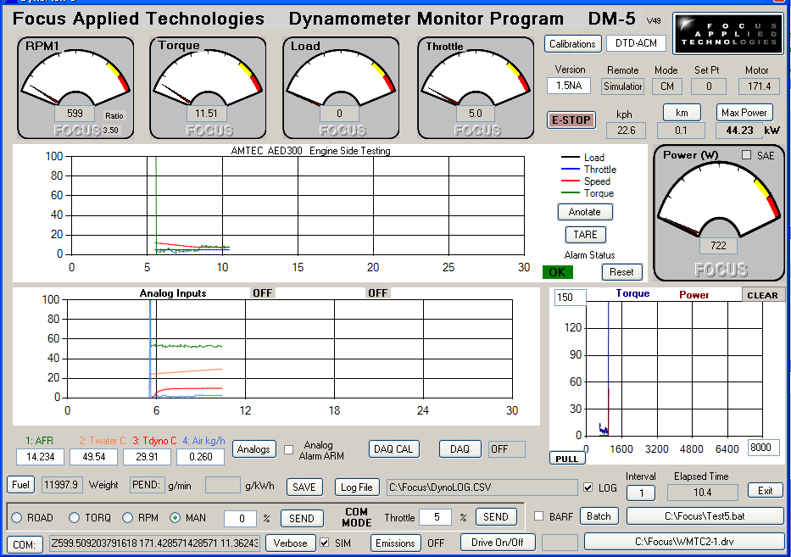
Once the software is in simulation mode, the results will be approximately correct for a 1.5 liter carbureted automotive engine. The dial gages, and graphs will become “live” once the simulation is running:

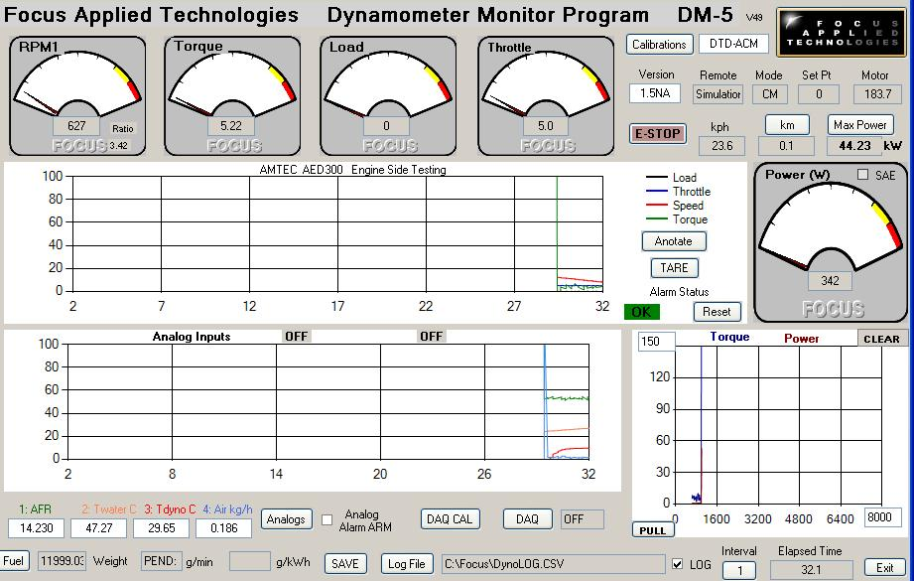

From the Dyno Monitor program you can control the operation of the dynamometer and engine, display and graph the results (eg. speed, power, torque) and save the data to a file for further analysis. This software is designed to work with our 5th generation Dynamometer Controller, but can be run in “stand alone” in simulation mode. More information on the controller and software can be found here:

http://www.focusappliedtechnologies.com/download/manual/DC5-Manual8.pdf
BRIEF INTRODUCTION TO DYNOMONITOR PROGRAM

A dynamometer is a load device that applies a load to a mechanical power source, or “prime mover” (ie. the engine or motor). The dynamometer controller is responsible for controlling the load, as well as measuring the speed and torque of the prime mover. This dynamometer controller allows the user to control the dynamometer load in several different modes: Manual, Speed, Torque, Road Load (RPM²). In each mode the set point is adjusted by rotating the Set Point Adjustment knob on the controller, or entering the desired set point into the left side COM MODE text box. Which of these modes to use depends on the specifics of your testing. For simple loading of an engine (ie. adding or reducing the load) the easiest mode is the Manual Control mode. For constant speed operation (Torque will vary) use the Speed Control mode. For constant torque, use the Torque Control more (Speed will vary). Road Load mode is commonly used to simulate the aerodynamic, acceleration and rolling resistance of a vehicle when operated on the road. In SIMULATION mode (eg. when the SIM check box at the bottom center is checked) only the MAN mode is available.

The operating point of the engine/dynamometer system is a result of the Dyno Load, and the engine Throttle which you provide to the controller and engine. In general greater throttles will result in higher torques and speed, and thus higher powers, while greater dynamometer loads will result in lower speeds of operation.

The pertinent data is displayed in the dial indicators on the software (eg. Speed, Torque, Load and Throttle), and power is calculated and displayed on the right. A “history” graph of the speed, torque, load and throttle is plotted on a scrolling horizontal graph in the center of the screen. Additionally several analog sensors are measured and displayed in text boxes below their history graph.

All data is saved to a Data Logging file, which can be renamed by clicking the Log File button near the bottom of the screen. Additionally averaged instantaneous data sets can be saved by hitting the “SAVE” button lower center of the screen.

For complete information we strongly recommend you download and read the dynamometer manual referenced above.

When running an experiment you will have to set the throttle and dynamometer load to get the appropriate test point. Normally this is done by physically manipulating the engine’s throttle (either via direct link, or from the dynamometer controller’s throttle control signal and servo motor), and the dyno load from the controllers front panel. In computer Control Mode, or Simulation Mode, you can control these by entering the desired Dyno Load and Throttle in the left and right COM MODE text boxes respectively. NOTE: You must hit the adjacent SEND button to submit the new throttle/load parameters to the controller. This is done to allow the use to manipulate both values in preparation for a simultaneous change.

You can adjust the throttle by changing the “Throttle” number (lower right) and hitting the SEND button. Note: You can use fractional throttle positions, eg. 55.3. The model has a “rev limiter” which will perform injection cut when the engine speed exceeds 7500 rpm. The simulation also has an “anti stall” mode, preventing operation below 600 rpm.

The dynamometers load can be adjusted by changing the Load% in the box at the lower left. NOTE: You can not use the RPM, Torque or Road load in this simulation, only “Manual” loading.

ENGINES LABORATORY STUDENT LABORATORY EXERCISE #1:
Petrol Engine Throttle Torque Curves (WOT and Part Throttle)

PURPOSE

The purpose of this laboratory exercise is to investigate the effect of throttle and engine torque on the torque and power of an internal combustion engine. The Efficiency of an Internal Combustion Engine varies widely depending on its operating point (speed and torque). Petrol engines have an air regulating throttle valve, giving them a characteristic torque curve at part throttles. In this exercise we measure the Wide Open Throttle (WOT) torque curve, and compare that with a Part Throttle Torque curve.

PROCEDURE

- Label your Log File with your group name on the desktop
- Place the Dynamometer Controller in MANual mode, 0% load
- Press “SAVE” to save the data to a data file (separately from the Log file with .DAT extension)
- Open the throttle to 100%. The engine will rev up to the “rev limiter” which cuts fuel above engine “redline” (7500 rpm), and this will trigger the “Over Speed” alarm which you can reset later.
- After a few seconds at the resulting speed press “SAVE” to get a no-load WOT speed reading
- Gradually increasing the manual load. Start with 10% increases, until the engine speed is reduced to below the “red line” speed, then increment by ~1% at a time.
- Once the engine is no longer rev-limited (eg. the speed stops oscillating and is reduced to below 7400 rpm) you can reset the “over speed” alarm.
- Hit the “SAVE” button every time the dyno crosses a 500 rpm threshold (ie. 7000, 6500, 6000, … down to 2500 rpm) and note the total torque (on computer screen) at these speeds
NOTE: It is not necessary to save the data exactly at the target speed, +/- 100 rpm is close enough
- Reduce the load to 0 and throttle to 5%
- Take a screen shot of the data by hitting the Logo in the upper right of the Dynomonitor screen
- Open the throttle to 50% and repeat the steps 7 to 10 (NOTE: The engine may not hit the higher speeds)
- Save all data, and check to make sure it is correct

Point RPM WOT Torque RPM 50% Throttle Torque
Target (rpm) rpm Nm rpm Nm
1 7000 _______ _______ _______ _______
2 6500 _______ _______ _______ _______
3 6000 _______ _______ _______ _______
4 5500 _______ _______ _______ ______ _
5 5000 _______ _______ _______ ______ _
6 4500 _______ _______ _______ _______
7 4000 _______ _______ _______ _______
8 3500 _______ _______ _______ _______
9 3000 _______ _______ _______ _______
10 2500 _______ _______ _______ _______

Graph the resulting Torque data points versus rpm.

DISCUSSION

Petrol engine are generally “air limited”, where the output torque is controlled by limiting the incoming air flow via an air throttle valve. At Wide Open Throttle the air flow is a function of valve timing, intake and exhaust tuning and various resistances and modifications of the air flow, including air heating. At part throttle the air flow is reduced via the throttle valve restriction. Flow resistance past the throttle valve increases as the air flow increases, thus the torque at part throttles drops off quickly as the engine speed is increased. From a given operating point if the engine speed up, it will intake less air (greater air resistance at higher speeds), thus reducing the torque, and thus the power. On the other hand if the engine is slowed, air flows in more freely increasing the torque, causing the engine to speed up.

Although different engine designs will have different torque curves, there are some nearly universal characteristics among typical 4-stroke spark ignited engines. At low speeds the hot combustion gasses have a longer residence time in the combustion chamber than they do at high speeds. This results in greater heating of the air and a loss in air density lowering the torque at lower speeds. In addition to this the valve timing is typically set up for good mid-range torque. As a result a fixed cam timing engine will suffer too much overlap between the intake and exhaust valve at low speeds. This will cause hot exhaust gasses to travel backwards into the intake system during the valve overlap period (ie. Intake Valve Open before Exhaust Valve Closed). This flow reversal will decrease the resulting volumetric efficiency, further reducing the low-speed torque. Also, air flow losses are proportional to the square of the flow speed. Thus, at higher speeds the flow losses greatly increase, reducing the volumetric efficiency of the engine, and thus the torque.

Maximum Torque
These factors typically result in a torque curve which has a maximum at about ½ to 2/3 of the red line speed. The point of maximum torque is an important parameter of an engine, and is typically specified as “Maximum Torque: 8Nm at 2800 rpm”. This is where the engine ingests the maximum amount of air per cycle, representing the maximum volumetric efficiency.

Maximum Power
Note that although the maximum volumetric efficiency typically occurs at an intermediate speed, this does not correspond to the maximum power. This is because power is the product of torque and speed. As we increase the speed of the engine past the maximum torque the torque drops off slightly, but the speed continues to increase. As long as the decrease in torque is less than the increase in speed, the power will increase as speed is increased. Generally maximum power will correspond to the redline speed, although if torque begins to drop off abruptly at high speeds the peak power may occur slightly before red line.

QUESTIONS

Based on your data answer the following questions:
1.1) What is your maximum torque?

1.2) At what speed does the maximum torque occur?

1.3) What was the maximum power of the engine?

1.4) At what speed did the maximum power occur?

1.5) What would the highest BMEP be for this engine, if it is a 1.5 liter 4-stroke engine?
Look up the meaning of BMEP and its definition if you don’t yet know.

1.6) Does the 50% throttle torque look like 0.5 x the 100% Throttle curve?

1.7) How much of your throttle range is useful at red line speed?

1.8) If then engine is suffering flow losses pumping air at part throttle settings, how will this effect the engine’s efficiency?

1.9) At higher speeds, will the engine be more efficient at 50% throttle or 100% throttle?

FOCUS ENGINES LABORATORY STUDENT LABORATORY EXERCISE #2:
BSFC vs Operating Condition

PURPOSE

The purpose of this laboratory exercise is to investigate the effect of throttle and engine torque on the fuel consumption of a spark ignited internal combustion engine. The Engine's theoretical efficiency can be as high as 30%, however in actual operation measured efficiencies are generally much lower. This is because the fuel consumption is a strong function of throttle/pumping losses, which vary with the throttle setting, and are minimized near Wide Open Throttle.

PROCEDURE

- Label your Log file as your group name on the Desktop
- Open the throttle, and add load to achieve 3000 rpm and 100Nm
NOTE: you do NOT need to get the speed and torque to match exactly, +/- 100 rpm and +/- 2Nm is close enough. If the torque or speed variation is too great, try increasing the filtering coefficient (from the Calibration menu)
- Once the BSCF reading is stable, record the speed, torque, power, and BSFC. This may take 60 seconds or more.
- Press “SAVE” to save the data to a data file (separately from the Log file with .DAT extension)
- Adjust the throttle and load to get 6000rpm and 50Nm
- Again once the BSCF reading is stable, record the speed, torque, power, and BSFC
- Press “SAVE” to save the data to a data file (separately from the Log file with .DAT extension)
- Adjust throttle and load to get 6000rm and 100Nm
- Once the BSCF reading is stable, record the speed, torque, power, and BSFC
- Press “SAVE” to save the data to a data file
- Adjust throttle and load to get 3000rm and 50Nm
- Once the BSCF reading is stable, record the speed, torque, power, and BSFC
- Press “SAVE” to save the data to a data file
- Save all data, and check to make sure it is correct

Point RPM Torque Power BSFC
Units: rpm Nm kW g/kWh
Target
1 3000, 100 _______ _______ _______ ______

2 6000, 50 _______ _______ _______ ______

3 6000, 100 _______ _______ _______ ______

4 3000 ,50 _______ _______ _______ ______

DISCUSSION

As the throttle is opened more air is allowed to enter the engine. Obviously more fuel is also required as well to maintain an appropriate Air/Fuel Ratio (AFR). As seen in the data, increasing the throttle increases the fuel flow rate, and the engine power as well. With a constant throttle, as the engine goes to higher speeds the engine makes more revolutions per minute, taking in more air. This is not necessarily more air per engine cycle, but there are more engine cycles per second. Thus we would expect the fuel consumption rate to increase as engine speed is increased even if the throttle is held constant. As the engine is producing more torque output cycles per second the power output is also increased.

The fuel weight is recorded automatically together with the power in the Log File. Plot the fuel weight and power versus time. You should notice that the slope of the fuel weight curve is directly proportional to the power: higher power levels mean a steeper slope (ie. faster consumption rate) of the fuel curve. The Fuel Consumption on the Dyno Monitor interface takes a 60 second measurement of the fuel weight change which is essentially a 60 second average measurement of the fuel flow rate. This measured number should match the slope of the fuel weight plotted on the graph.

As the throttle is opened air is allowed to enter the engine more easily, reducing the losses of air flowing past the throttle. In the first two data points (3000rpm, 100Nm and 6000rpm, 50Nm) the power is kept constant as the throttle is decreased. Although the power should be the same at these two pints, the pumping losses will be much greater at the high speed, and lower throttle setting, increasing the fuel consumption. Additionally the engine’s mechanical friction increases with engine speed. To compare the relative fuel consumption of different engines or conditions we typically use the Break Specific Fuel Consumption (BSFC) which is the fuel consumption (in grams per hour) divided by the power production (in kW). Automotive carbureted four-stroke spark ignited engines will typically have a best BSFC in the range of 200 - 300 gm/kWh, but smaller engines have proportionally more friction, and thus the BSFC is a little higher. The BSFC is an indication of the efficiency of the engine: a smaller BSFC number indicates more efficient conversion of the fuel to shaft power.

Plot your test points on a torque versus speed graph along with the Wide Open Throttle torque curve of Lab 1. At each point write the calculated power and, BSFC number. Notice the trend in BSCF as the throttle is opened at a constant speed. Although power and fuel consumption is increasing the BSFC is decreasing. This indicates that the engine is operating more efficiently as we get closer to 100% throttle. At 100% throttle we lose less energy to pumping losses of the intake air passing the throttle.

QUESTIONS

Based on your data answer the following questions:
2.1) Does your fuel consumption rate match the slope plotted on the graph?

2.2) It was stated that the fuel consumption is approximately proportional to power. Do your numbers show this?

2.3) What could be a reason for the variation in the BSCF?

2.4) What is the biggest difference in BSFC of the measured points?

2.5) How much fuel more fuel is consumed per unit work in the least efficient point compared to the most efficient point?

2.6) If a car traveling at 125kph requires about 32kW of power, this can be satisfied by operating the engine at 3000rpm and 100Nm in high gear, or 6000rpm and 50Nm in a lower gear. What would the resulting mileages (in kilometers per liter) be for the two operating points?

